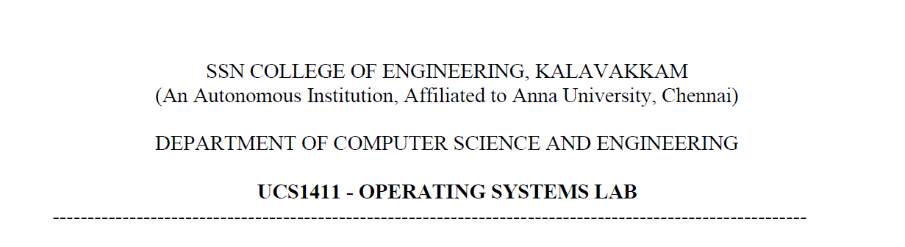

**NETWORKS LAB**

**EXERCISE 7**

Name: Jayannthan P T

Dept: CSE ‘A’

Roll No.: 205001049

HTTP web client program to download the webpage TCP

**Aim:**

Implement a HTTP web client program to download the webpage using C socket programming.

**Algorithm:**

1. Read the name of the server as command line argument

*(Ex: www.ssn.edu.in/wp-content/uploads/2021/02/NIRF-2021-SSNCE-ENGG.pdf)*

1. Get the address of the server using gethostbyname() that returns the pointer to network data structure for given host.
2. Create a TCP socket using socket().
3. Connect to remote server.
4. Send request using a GET /path/filename HTTP/1.1\r\n request using either send() or write().

*(GET /wp-content/uploads/2021/02/NIRF-2021-SSNCE-ENGG.pdf HTTP/1.1\r\nHost: www.ssn.edu.in \r\n\r\n)*

1. Receive the response using either recv() or read().
2. Parse the response to find out if the request succeeded and what format the file data is being sent as.
3. Receive the file data, if present, using either recv() or read() and write the downloaded page into file under a different name in a local folder.
4. Close the socket and the file.

**Code:**

#include<stdio.h>

#include<stdlib.h>

#include<string.h>

#include<unistd.h>

#include<fcntl.h>

#include<netdb.h>

#include<sys/types.h>

#include<sys/socket.h>

#include<arpa/inet.h>

#define SERVER_TCP_PORT 80

**int** main(**int** argc, **char** * argv**[]**) {

**int** sockfd, len;

**char** hostname[20], path[100], request[120], response[1024], newfile[30];

**struct** sockaddr_in serveraddr;

    if (argc == 1)

    {

        printf("Enter URL in command line argument\n");

        return 0;

    }

**int** i,j;

    for (i = 0; i < strlen(argv[1]); i++)

    {

        if (argv[1][i] != '/')

        {

            hostname[i] = argv[1][i];

        }

        else

        {

            break;

        }

    }

    for (i = i, j = 0; i < strlen(argv[1]); i++, j++)

    {

        path[j] = argv[1][i];

    }

    path[j] = '\0';

    strcpy(request, "GET ");

    strcat(request, path);

    strcat(request, " HTTP/1.1\r\nHost: ");

    strcat(request, hostname);

    strcat(request, "\r\n\r\n");

**struct** hostent * host = gethostbyname(hostname);

    sockfd = socket(AF_INET, SOCK_STREAM, 0);

    serveraddr.sin_family = AF_INET;

    serveraddr.sin_addr = * ((**struct** in_addr * ) host -> h_addr);

    serveraddr.sin_port = htons(SERVER_TCP_PORT);

    connect(sockfd, (**struct** sockaddr * ) & serveraddr, sizeof(serveraddr));

    write(sockfd, request, strlen(request));

    len = read(sockfd, response, 1024);

    close(sockfd);

    printf("Enter file name to save: ");

    scanf("%s", newfile);

    FILE * fd = fopen(newfile, "w+");

    fwrite(response, 1, len, fd);

    fclose(fd);

    printf("Downloaded file saved under %s\n", newfile);

    return 0;

}

**Output:**

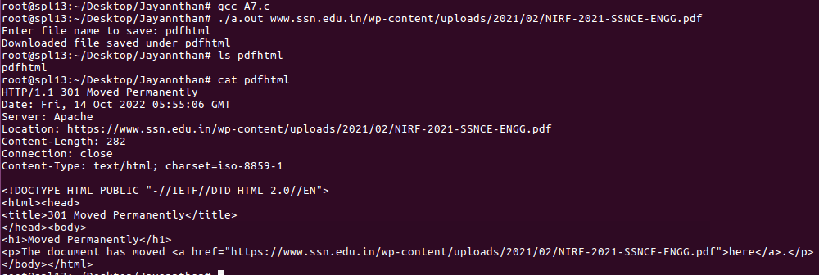

**Learning outcome:**

Learnt to implement a HTTP web client program